# Exam 2 Part 2

**Problem 1:**

syms x;

y = 3*x^5 * (sin(5*x))^2 + 100*exp(-4*x) * cos(3*x);

% Calculate the first derivative

dydx = diff(y, x);

% Calculate the second derivative

d2ydx2 = diff(dydx, x);

% Evaluate the first derivative at x=0.01

x_val_1 = 0.01;

dydx_at_x_val_1 = double(subs(dydx, x, x_val_1));

% Evaluate the second derivative at x=0.1

x_val_2 = 0.1;

d2ydx2_at_x_val_2 = double(subs(d2ydx2, x, x_val_2));

% Display the results

disp(['First derivative at x=0.01 is: ' num2str(dydx_at_x_val_1)]);

disp(['Second derivative at x=0.1 is: ' num2str(d2ydx2_at_x_val_2)]);

First derivative at x=0.01 is: **-392.7887**

Second derivative at x=0.1 is: **923.7175**

**Problem 2:**

syms x;

y = 3*x^5 * (sin(5*x))^2 + 100*exp(-4*x) * cos(3*x);

% Calculate the definite integral over the interval -1 to 3

integral_value = int(y, x, -1, 3);

integral_value = double(integral_value);

% Display the result

disp(['The value of the integral over the interval -1 to 3 is: ' num2str(integral_value)])

The value of the integral over the interval -1 to 3 is: **-556.1969**

**Problem 3:**

syms t y(t);

dydt = diff(y, t) == 5*cos(6*t) + 20;

% Define the initial condition

y0 = y(0) == 40;

% Solve the differential equation

sol = dsolve(dydt, y0);

% Evaluate at t=10

t0 = 10;

y_t = subs(sol, t, t0);

y_t = double(y_t);

% Display the result

disp(['The value of y at t=10 is: ' num2str(y_t)]);

The value of y at t=10 is: **239.746**

**Problem 4:**

syms t y(t)

eq = diff(y, t, t) + 5*diff(y, t) + 6*y == 5*cos(6*t) + 20;

dy = diff(y, t);

y0 = y(0) == 20;

dy0 = dy(0) == 0;

% Solve the differential equation

y = dsolve(eq, [y0, dy0]);

% Evaluate y at t = 10

t_value = 10;

y_value = subs(y, t, t_value);

y_value = double(y_value);

disp(['The value of y for t = 10 is: ', num2str(y_value)]);

The value of y for t = 10 is: **3.3873**

**Problem 5:**

% Define the function

x = linspace(0, 5, 21); % Case (a): 21 points

y = 2 * exp(-x) .* sin(3 * x.^2);

% Calculate the exact derivative

exact_derivative = -2 * exp(-x) .* (sin(3 * x.^2) - 6 * x.^2 .* cos(3 * x.^2));

% Calculate the approximate derivative

h = x(2) - x(1);

approx_derivative = diff(y) / h;

% Exact value of y' for x = 2.25

x_exact = 2.25;

exact_derivative_2_25 = -2 * exp(-x_exact) * (sin(3 * x_exact^2) - 6 * x_exact^2 * cos(3 * x_exact^2));

% Approximate value of y' for x = 2.25 with N = 21

index_2_25 = find(x <= x_exact, 1, 'last');

approx_derivative_2_25_21 = approx_derivative(index_2_25);

figure;

% Subplot for case (a)

subplot(1, 2, 1);

plot(x, exact_derivative, 'b', x(1:end-1), approx_derivative, 'r');

title('21 Points');

legend('Exact Derivative', 'Approximate Derivative');

xlabel('x');

ylabel('Derivative');

% Define the function with 501 points

x = linspace(0, 5, 501); % Case (b): 501 points

y = 2 * exp(-x) .* sin(3 * x.^2);

% Calculate the exact derivative

exact_derivative = -2 * exp(-x) .* (sin(3 * x.^2) - 6 * x.^2 .* cos(3 * x.^2));

% Calculate the approximate derivative

h = x(2) - x(1);

approx_derivative = diff(y) / h;

% Subplot for case (b)

subplot(1, 2, 2);

plot(x, exact_derivative, 'b', x(1:end-1), approx_derivative, 'r');

title('501 Points');

legend('Exact Derivative', 'Approximate Derivative');

xlabel('x');

ylabel('Derivative');

% Exact value of y' for x = 2.3

x_exact = 2.3;

exact_derivative_2_3 = -2 * exp(-x_exact) * (sin(3 * x_exact^2) - 6 * x_exact^2 * cos(3 * x_exact^2));

% Approximate value of y' for x = 2.3 with N = 501

index_2_3 = find(x <= x_exact, 1, 'last');

approx_derivative_2_3_501 = approx_derivative(index_2_3);

% Display the results

disp(['Exact value of y'' for x = 2.25: ', num2str(exact_derivative_2_25)]);

disp(['Approx value of y'' for x = 2.25 with N = 21: ', num2str(approx_derivative_2_25_21)]);

disp(['Exact value of y'' for x = 2.3: ', num2str(exact_derivative_2_3)]);

disp(['Approx value of y'' for x = 2.3 with N = 501: ', num2str(approx_derivative_2_3_501)]);

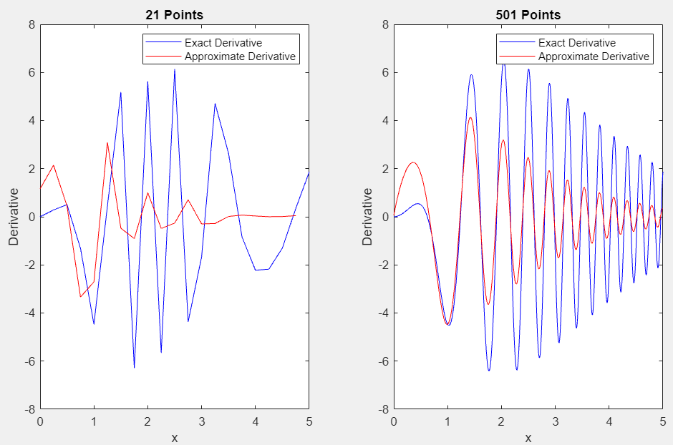

Exact value of y' for x = 2.25: **-2.5738**

Approx value of y' for x = 2.25 with N = 21: **-0.4846**

Exact value of y' for x = 2.3: **-2.6985**

Approx value of y' for x = 2.3 with N = 501: **-2.6382**

**Problem 6:**

syms x;

f(x) = 10 * exp(-x/2) * (sin(5*x))^2;

% (a) Exact integral using symbolic integration

exact_integral = int(f, 0, 10);

exact_integral = double(exact_integral);

% (b) Zero-order approximation

step = 0.01;

x_values = 0:step:10;

b_integral = sum(f(x_values)) * step;

b_integral = double(b_integral);

% (c) First-order approximation

c_integral = trapz(x_values, f(x_values));

c_integral = double(c_integral);

% Plot the exact and approximate integrals

figure;

plot(x_values, cumsum(f(x_values) * step), 'r', 'LineWidth', 2);

hold on;

plot([0, 10], [0, exact_integral], 'b--', 'LineWidth', 2);

legend('Approximate Integral', 'Exact Integral', 'Location', 'Best');

xlabel('x');

ylabel('Integral Value');

title('Exact and Approximate Integrals');

% Display the results

disp(['Exact value of the integral for 0 to 10: ', num2str(exact_integral)]);

disp(['Approximate value of the integral for 0 to 10 (Zero-order Approximation): ', num2str(b_integral)]);

disp(['Approximate value of the integral for 0 to 10 (First-order Approximation): ', num2str(c_integral)]);

Exact value of the integral for 0 to 10: **9.9095**

Approximate value of the integral for 0 to 10 (Zero-order Approximation): **9.9096**

Approximate value of the integral for 0 to 10 (First-order Approximation): **9.9095**

